Aerospace Technology Research at the
UNIVERSITAT POLITÈCNICA DE CATALUNYA

May, 2003

Foreword

Aerospace is certainly a multidisciplinary field. It is hard to imagine some discipline of science or engineering that has not some kind of impact on the development of air navigation and space exploration at large.
This report includes reference information on groups and research activities developed in universities and research centers at UPC and, for clarity, it lists only those with a direct involvement in aircraft design and operations, navigation, satellite communications and ground monitoring and the environment. These are the topics considered as a priority in the development of an European Framework for research on Aeronautics and Space.
There is no doubt that the excellence of many related research activities carried out may not be reflected in this document to their full extent. However, a first glance at the wide variety of the past and on-going work reported here will quickly evidence a sign of modernity, the continuous work of our investigators and the fruitful outcome that has made UPC a leading academic institution in industrial and technological development.

Table of Contents
1 Aeronautical and Space Communications 4
1.1 Aerospace Communications Signal Processing 4
1.2 High-Altitude Platforms (HAPs) 5
2 Aerospace Fluid Dynamics 6
2.1 Aerodynamics of aircrafts and aerospace vehicles 6
2.2 Computational models for flow problems 7
3 Aerospace Materials 8
3.1 Analysis of Structures with Composite Materials 8
3.2 Mechanical Behaviour of metals and ceramics (CIEFMA) 9
4 Airport Infrastructures and Logistics 10
4.1 Center for Transport Innovation (CENIT) 10
5 Control Systems 11
5.1 Advanced Control Systems 11
6 Environmental Aeronautics 12
6.1 Laboratory for Acoustics and Mechanical Engineering (LEAM) 12
7 Navigation and Positioning Systems 13
7.1 Electromagnetics and Photonics Engineering (EEF) 13
7.1.1 Navigation and Radar Systems 13
7.1.2 Synthetic Aperture Radar (SAR) 13
7.2 Earth Sciences and Space Geodesy: Satellite Altimetry 14
7.3 Astronomy and Geomatics (gAGE) 15
8 Aerospace Research Training 16
8.1 Doctoral Program in Aerospace Science and Technology 16

Aeronautical and Space Communications

Aerospace Communications Signal Processing

Activities: Space-related research activities and commercial applications include Ground and On-Board Satellite Processing for Digital Communications (synchronisation, multiplexing and demultiplexing, adaptive beamforming, On-Board-Processing for multiuser demodulation, channel coding, ASIC implementation), Satellite Navigation Systems (synchronisation, multipath and interference cancellation), Array processing (adaptive beamforming, wideband array processing, spatial source localisation and tracking).
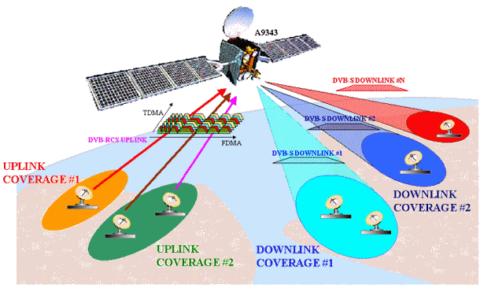
Selected projects:
Space Division Multiple Access (SDMA): Incorporation of Smart Antennas into mobile communication systems permits the introduction of the SDMA access technique that can be efficiently combined with both Time and Code Division Multiple Access (TDMA and CDMA). When combined with TDMA it allows more than one user to share the same time slot. When incorporated into a CDMA system, SDMA will reduce both the inter and intra cell multiple access interference. In both cases a substantial capacity increase can be achieved; Development of Digital Modems for ATM (Air Traffic Management): For the GNSS system, a transponder unit can be installed in airplanes, vehicles and at ground base stations. The transponder transmit the information about position of vehicles on a Time Division Multiple Access (TDMA), VHF data link to other users in the system. Differential global positioning system corrections from the base stations are broadcasted on the same data link. In order to design a full digital modem for this application D8PSK and GMSK modulation formats have been used, with channel codification (RS codes).
Host institution: Universitat Politècnica de Catalunya (UPC)
Department: Signal Theory and Communications (739)
Research line: 33259913-00 - PROCESSAMENT DEL SENYAL EN RADAR, SONAR I SISTEMES DE COMUNICACIÓ
Web page: http://gps-tsc.upc.es/comm
Contact: Prof. Gregori Vázquez (gregori@gps.tsc.upc.es)

High-Altitude Platforms (HAPs)
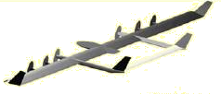
Activities: Radiocommunications: Digital transmission (fix or mobile)systems for 3Mhz-30 Ghz bands; Channel modelling and characterization; Radioelectric planning by simulation; Modelling and simulation of Telecommunication systems: Analysis/design by digital simulation using Topsim and Simulink(Matlab) Digital TV systems based on DVB: DVB-C;DVBT; DVB-S. Analysis and Design. Evaluation of implemented systems. UAV/HAPS : Radiocommunication systems (Telemetry and Telecommand). Telecontrol: SEE,Avionics,Aircraft control, localization SCADA systems Supervision and control: acquisition and signal processing for supervision and control for rivers, sea and lakes.
Selected projects: HAPS participates in the following European projects/activities: ¨IST-HeliNet: Network of stratospheric platforms for traffic monitoring, environmental surveillance and broadband services. ¨ UCARE: Thematic network initiative of Euro-uvs (European organisation on UAV). ¨ COST 280: Impairment mitigation for millimetre wave radio systems.
Host institution: Universitat Politècnica de Catalunya (UPC)
Department: Signal Theory and Communications (739)
Research lines: 33110202-00 - SISTEMES DE CONTROL DIGITAL I ADAPTATIU; 33259921-00-RADIOCOMUNICACIONS DIGITALS EN ONES DECAMÈTRIQUES, DECIMÈTRIQUES I MILIMÈTRIQUES
Web page: http://www-tsc.upc.es/engl/research/rschgroups/haps/haps.htm
Contacts: Prof. José A. Delgado-Penín ( delpen@tsc.upc.es ) – Communications
Prof. Eduard Bertran (bertran@tsc.upc.es ) – Control.

Aerospace Fluid Dynamics

Aerodynamics of aircrafts and aerospace vehicles

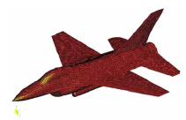
Activities: Development of stabilized numerical methods for fluid flow problems. Advanced finite element methods for incompressible and compressible flows. Mesh-free finite point method for fluid flow analysis. Coupled fluid-structure interaction analysis. Numerical methods for fluid-thermal problems. Mesh generation and visualization of results in fluid flow problems.
Recent projects: ECARP: European Computational Aerodynamics Research Project (Brite-Euram, EU); Porting and demostration of a parallel solver for enhanced aerodynamic and acoustic design (Esprit, EU); PROMUVAL: Prospective study on the state of the art of multidisciplinary modeling. Simulation and validation in aeronautics (Growth Programme, EU).
Host institutions: International Centre for Numerical Methods in Engineering (CIMNE) and Universitat Politècnica de Catalunya (UPC)
Web page: http://www.cimne.upc.es
Contact: Prof. Eugenio Oñate (onate@cimne.upc.es)

Computational models for flow problems
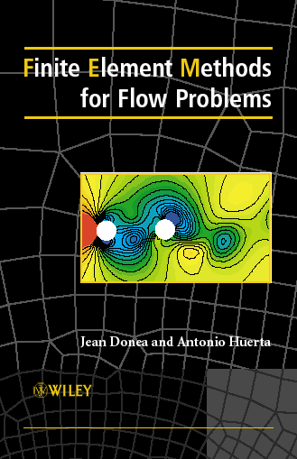
Activities: Computer methods in applied sciences and engineering, concerning both (1) the development, analysis, implementation and validation of numerical methods and (2) the application to real problems in applied sciences and engineering. Methods: finite elements, mesh-free methods, error estimation and adaptivity, error control, mesh generation, nonlinear systems of equations. Applications: quality of the computations, aeroelasticity, convection-diffusion, flow & acoustics, fluid-structure interaction, failure and postfailure, large-strain problems, shape optimization.
Recent projects: Time-accurate solution of stabilized convection-diffusion-reaction equations: Time and space discretization; Implementation of a stabilized finite element formulation for the incompressible Navier-Stokes equations based on a pressure gradient projection
Host institution: Universitat Politècnica de Catalunya (UPC)
Department: Applied Mathematics III (727)
Research line: 12060002-00 - MÈTODES NUMÈRICS EN CIÈNCIES APLICADES I ENGINYERIA
Web page: http://www-lacan.upc.es
Contact: contact.lacan@upc.es

Aerospace Materials

Analysis of Structures with Composite Materials
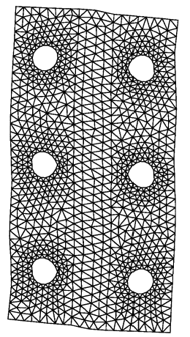
Activities: Constitutive models of the behavior of the materials. Numerical and mechanical treatment of the fatigue in metals and composites, powder metallurgy and ceramics. Dynamics of structures and study of the damage. Numerical and mechanical study of geomaterials and their interaction with thermal and mechanical loads, Parallel computing of industrial processes, Metal forming studies.
Recent projects: ALSTAMP: Trial of a sheet stamping simulation system in the aluminum packaging and aerospace sectors (IST Programme, EU); A methodology for durability assessment of composite materials and aerospace structures under cyclic loads (Growth Programme, EU).
Host institution: International Centre for Numetical Methods in Engineering (CIMNE) and Universitat Politècnica de Catalunya (UPC)
Research line: 33053202-00 - ANÀLISI D'ESTRUCTURES I DE MECÀNICA DE MEDIS CONTINUS
Web page: http://www.cimne.upc.es/
Contact: Prof. Sergio Oller (sergio.oller@upc.es)

Mechanical Behaviour of metals and ceramics (CIEFMA)
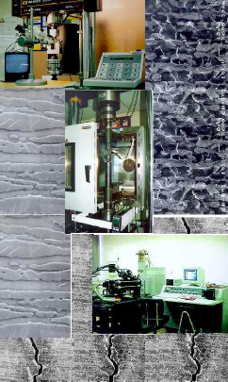
Activities: Fatigue, fracture and micro-mechanisms of deformation of materials with application in aeronautics: metals, ceramics and composites. Development of new techniques of instrumental indentation and finite-element modelling of contact mechanisms. Study of the structural integrity and reliability of multi-layer ceramics, ceramic coatings and thermal shields.
CIEFMA (Center for Structural Reliability and Integrity of Materials) focusses research and development on topics of structural reliability of aerospace materials and industrial components. Main interests are mechanical testing of materials, development of new testing methods for evaluation of materials and components behaviour for specific applications, training in materials technology and technology transfer. Specific applications include: Structural ceramics for high temperature applications and composites materials; Fatigue of aerospace powder metallurgy alloys; Study of integrity of ceramic coatings and thermal barriers; Fracture and fatigue behaviour of titanium alloys; Mechanical behaviour of hard materials used as cutting tools; development of novel instrumented indentation techniques and finite element modelling of contact mechanics.
Recent Projects: Coordination of an European Research Training Network on Ceramic coatings and multilayers and thermal barriers (EU Project); Dual Material Titanium Alloy Friction Welded BLISK (DUTIFRISK)
Host institution: Universitat Politècnica de Catalunya (UPC)
Department: Materials Science and Metallurgical Engineering (702)
Research line: 33120902-00 - COMPORTAMENT MECÀNIC DE METALLS I CERÀMIQUES
Web page: http://www.upc.es/web/ciefma/
Contact: Prof. Marc Anglada (anglada@cmem.upc.es)

Airport Infrastructures and Logistics

Center for Transport Innovation (CENIT)

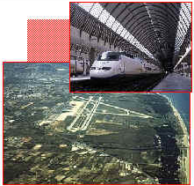
Activities: Airport design and operations, airplane occupation strategies and optimization, road management, planning and functional design of transportation systems, operations optimization and quality of public transportation, logistics and transport of goods.
CENIT has carried out a large number of research, development and technological transfer projects in different areas of transport economy and engineering, always trying to focus research on the demands of social players in specific areas and lines.
It works in the planning and functional design of railways and transportation systems, the simulation of demand for transportation (railways, public transport, transit, freight) and demand forecasts, optimization of operations and logistic costs, reports on transportation, assessment of the economic, financial and social profitability of projects, and the transportation system.
It participates in European projects (OD-ESTIM, the Barcelona-Narbonne TGV, UK shadow tolls) and Latin-American ones.
Projects: Connections between high-speed railway lines and airports in Europe. RACC Foundation. Objectives: Analysis of European experience in the establishment of high-speed links with European airports.
Host institution: Universitat Politècnica de Catalunya (UPC)
Department: Transportation and Land Infrastructures (722)
Research line: 33270301-00 - MODELITZACIÓ I ANÀLISI DE SISTEMES DE TRANSPORT
Web page: http://www-cenit.upc.es/web/eng/research.htm
Contact: Prof. Francesc Robusté (f.robuste@upc.es) - Airport Logistics

Control Systems

Advanced Control Systems
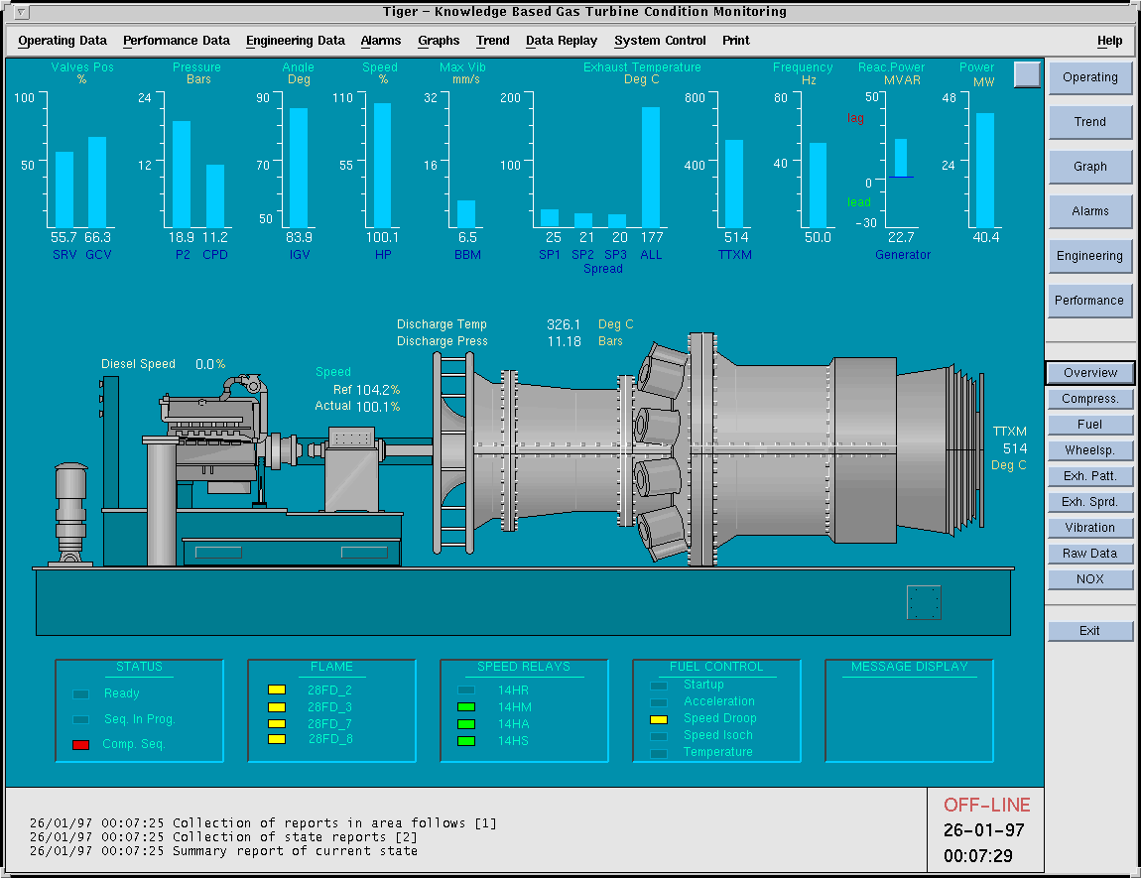
Activities: The main objectives of this line of research include the development of new modelling techniques, simulation and analysis of complex systems, as well as the design of new algorithms for advanced, adaptive, expert, robust and neuronal control of complex processes. New simulation techniques are developed using object-oriented progamming, and presentations of advanced control systems are evaluated in test beds with real laboratory processes, including aerolevitators, and pH-flow-temperature control systems, among others.
Selected Projects: Two european projects TIGER (1992-1995) and its follow-up programTIGER-SHEBA (2000-2002) dealing with real-time monitoring and supervision of gas turbines. TIGER focussed on the analysis of an auxiliary turbine manufactured by Turbomechanique for DASSAULT airplanes. TIGER-SHEBA, is an extension of TIGER and was awarded second the Duran i Farell Prize for Technological Research.
Host institution: Universitat Politècnica de Catalunya (UPC)
Department: Systems Engineering, Automatics and Industrial Informatics (707)
Research line: 12039901-00 - SISTEMES AVANÇATS DE CONTROL
Web page: http://webesaii.upc.es/rec/hea/sac/ct/
Contact: Prof. Joseba-Jokin Quevedo (joseba@esaii.upc.es)

Environmental Aeronautics

Laboratory for Acoustics and Mechanical Engineering (LEAM)
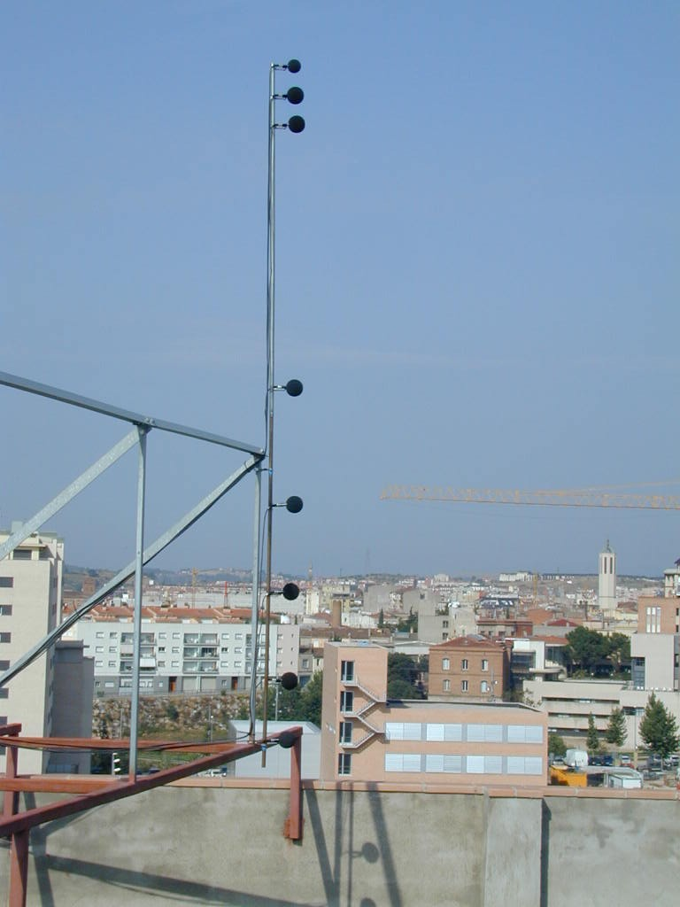
Activities: Design of low acoustic emission products. Noise reduction and manufacturing processes. Management of environmental noise. Acoustic maps. Acoustic impact of transportation infrastructures: airports, roads and railways.
LEAM is involved in a wide variety of research activities related to the analysis and reduction of environmental effects of noise in urban areas.
Projects: Aircraft Noise Control: The main objective is noise reduction in aircraft cabins. Work focusses on the validation of calculation and prediction systems, as well as active noise control systems. Current projects on this topic include Modelisation of the Vibroacoustic Behaviour of Complex Partitions with the SEA Method (with SENER); Integrated Noise Control Systems in Cabin Seats (with Air Catalunya); Aircraft Structural Noise Active Control (FP6 proposal).
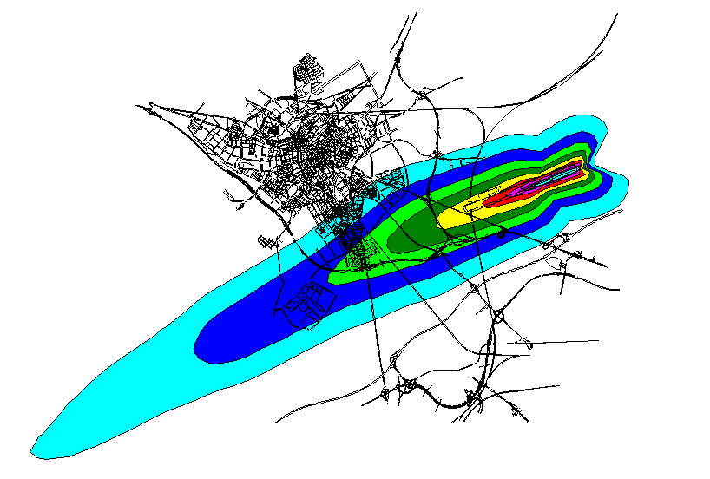
Airport Noise Control: Collaboration with AENA (Spanish Air Navigation Authority) on the evaluation of the acoustic impact of the Barcelona and Reus airports. This includes development of array measurements intended to discriminate automatically aircraft noise from urban acoustic pollution. Project proposal: L’intégration environnementale des aéroports sur le territoire (MEDOCC – INTERREG IIIB) for the application of active noise control techniques.
Host institution: Universitat Politècnica de Catalunya (UPC)
Department: Mechanical Engineering (712)
Research line: 22010501-00 - CONTAMINACIÓ AMBIENTAL PER EMISSIÓ ACÚSTICA
Web page: http://leam.upc.es
Contact: Prof. Jordi Romeu (jordi.romeu@upc.es)

Navigation and Positioning Systems

Electromagnetics and Photonics Engineering (EEF)

Navigation and Radar Systems
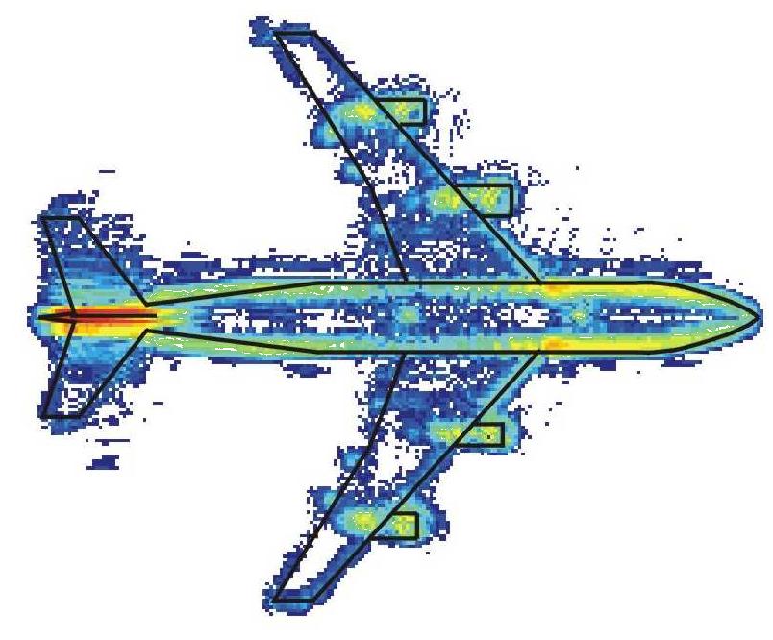
Activities: Radar systems and technologies for air traffic control and surveillance. Bistatic radars. Inverse synthetic aperture radar imaging of aircraft. Microwave Remote Sensing. Synthetic Aperture Radars and Scatterometers for ground based, airborne and spaceborne applications. Electromagnetic scattering modeling of natural surfaces and retrieval of geophysical parameters. Radar interferometry and polarimetry for topographic and thematic mapping. Integrated processing systems for automatic exploitation of remote sensing spaceborne and airborne data.
Selected Projects: Development of a three-dimensional, L Band, solid state Radar for defense and air traffic control applications; Development of an integral system for air traffic surveillance in non-cooperative environments; Remote synchronization of signals in radar and communications. Multistatic radars, synchronization, geometry and detection; Laser radar systems for atmosphere probing and for hard-target speed detection; Specification and Analysis Study of Surveillance Primary Radars.
Contact: Prof. Antoni Broquetas (toni@tsc.upc.es)

Synthetic Aperture Radar (SAR)
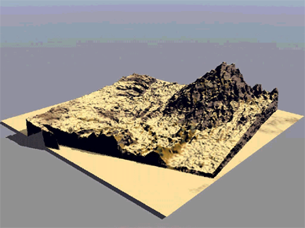
Activities: Study and measurement of the thermal radiation emitted and/or reflected by the Earth and the atmosphere, including: SAR processors for raw data processing. Experience with both orbital (ERS, ESA) and airborne (E-SAR, DLR) sensors; Parallelism techniques applied to SAR processing; Interferometric processing chain from raw data to geocoded DEM; Differential interferometric chain using multitemporal SAR images for subsidence monitoring.
… to maps
Selected projects: ESA Pilot Project: 1992-1994 ERS-1 SAR exploitation; Exploitation of SAR interferometry in the production of Digital Elevation; AMPER: Application of Multi-Parameter Polarimetry in Enviromental Remote Sensing (ESA EO); MIRAS Demonstrator Pilot Project-2 (MDPP-2)”, EADS CASA (Subcontrator European Space Agency).
Contact: Prof. Adriano Camps (camps@tsc.upc.es)
Host institution for EEF: Universitat Politècnica de Catalunya (UPC)
Department: Signal Theory and Communications (739)
Research lines: 33250601-00 - TELEDETECCIÓ PER MICROONES; 33071000-00 - SISTEMES RADAR I RADIONAVEGACIÓ;
Web page: http://www-tsc.upc.es/eef/research_lines/research.htm

Earth Sciences and Space Geodesy: Satellite Altimetry
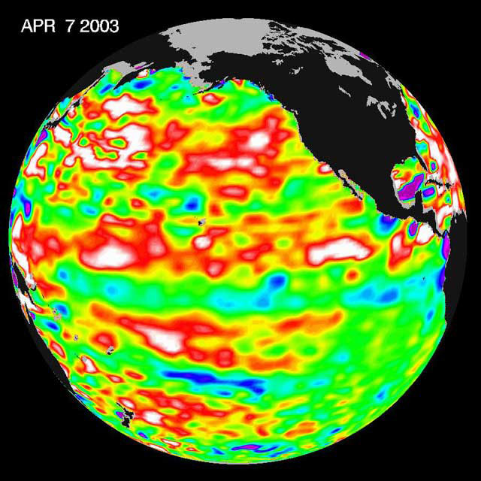
Activities: Study of the characteristics of oceanographic satellite movements. Satellite image processing. Treatment of altimetric data and applications on Space Oceanography. Validation of satellite orbits for altimetric data. Environmental studies of the Mediterranean sea.
Selected Projects: Space Geodesy and Altimetry for Monitoring Sea Level and Environmental Conditions in the Mediterranean Sea (Spanish National Space Program); “European Sea Level Service Research Infrastructure, ESEAS-RI (FP5, EU). Satellite Altimetry: calibration, orbit validation and processing of altimetric data from TOPEX/POSEIDON, ERS-2 y GFO-1 in the western Mediterranean.
Host institution: Universitat Politècnica de Catalunya (UPC)
Department: Applied Physics (720)
Research line: 25091901-00 - METEOROLOGIA APLICADA: CANVI CLIMÀTIC I MEDI AMBIENT
Web page: http://www-fa.upc.es/lineas/meteo/meteo.html
Contact: Prof. Juan José Martínez-Benjamín (benjamin@fa.upc.es)

Astronomy and Geomatics (gAGE)
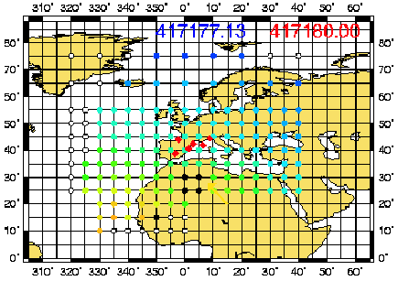
Activities: Ionospheric Tomography: Use of GPS satellite constellation, earth receivers and LEO sounding. Real-Time Ionospheric Models for Precise Radionavigation using GPS: subdecimetric navigation algorithms and strategies for WADGPS networks GPS (hundreds of kilometers far from reference stations), based on accurate real-time ionospheric models.
Selected projects: IONEX, Ionospheric daily and planetary map generation using the International GPS Service earth stations network (gaGE/UPC is one of the five Official IGS Centers for IONEX product generation and analysis; IRI/GPS: Assimilation of the ionospheric estimations obtained by GPS data to the International Reference Ionosphere model. Collaboration between the Goddard Space Flight Center (NASA) and gAGE/UPC since 1997 on the actualization of the IRI reference model by means of inclusion of information coming from ionospheric sounding performed by GPS constellation satellites. IGUANA: Integration of a GNSS permanent receiver as an ionospheric and tropospheric monitor tool.
Host institution: Universitat Politècnica de Catalunya (UPC)
Departments: Applied Mathematics IV (743) and Applied Physics (720)
Research line: 21011102-00 - ASTRONOMIA I GEODÈSIA ESPACIAL
Web page: http://gage1.upc.es
Contact: Prof. Manuel Hernández-Pajares (manuel@mat.upc.es)

Aerospace Research Training

Doctoral Program in Aerospace Science and Technology
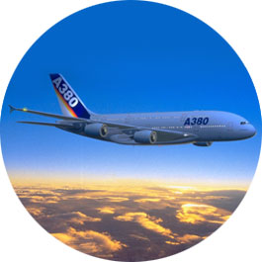
The Ph.D. in Aerospace Science and Technology (DoCTA) is a joint program of different departments in the fields of telecommunications, industrial and civil engineering and the basic sciences. The Program is structured following the main lines that offer research training and guidance on the sciences and technologies of the aeronautical and space sectors.
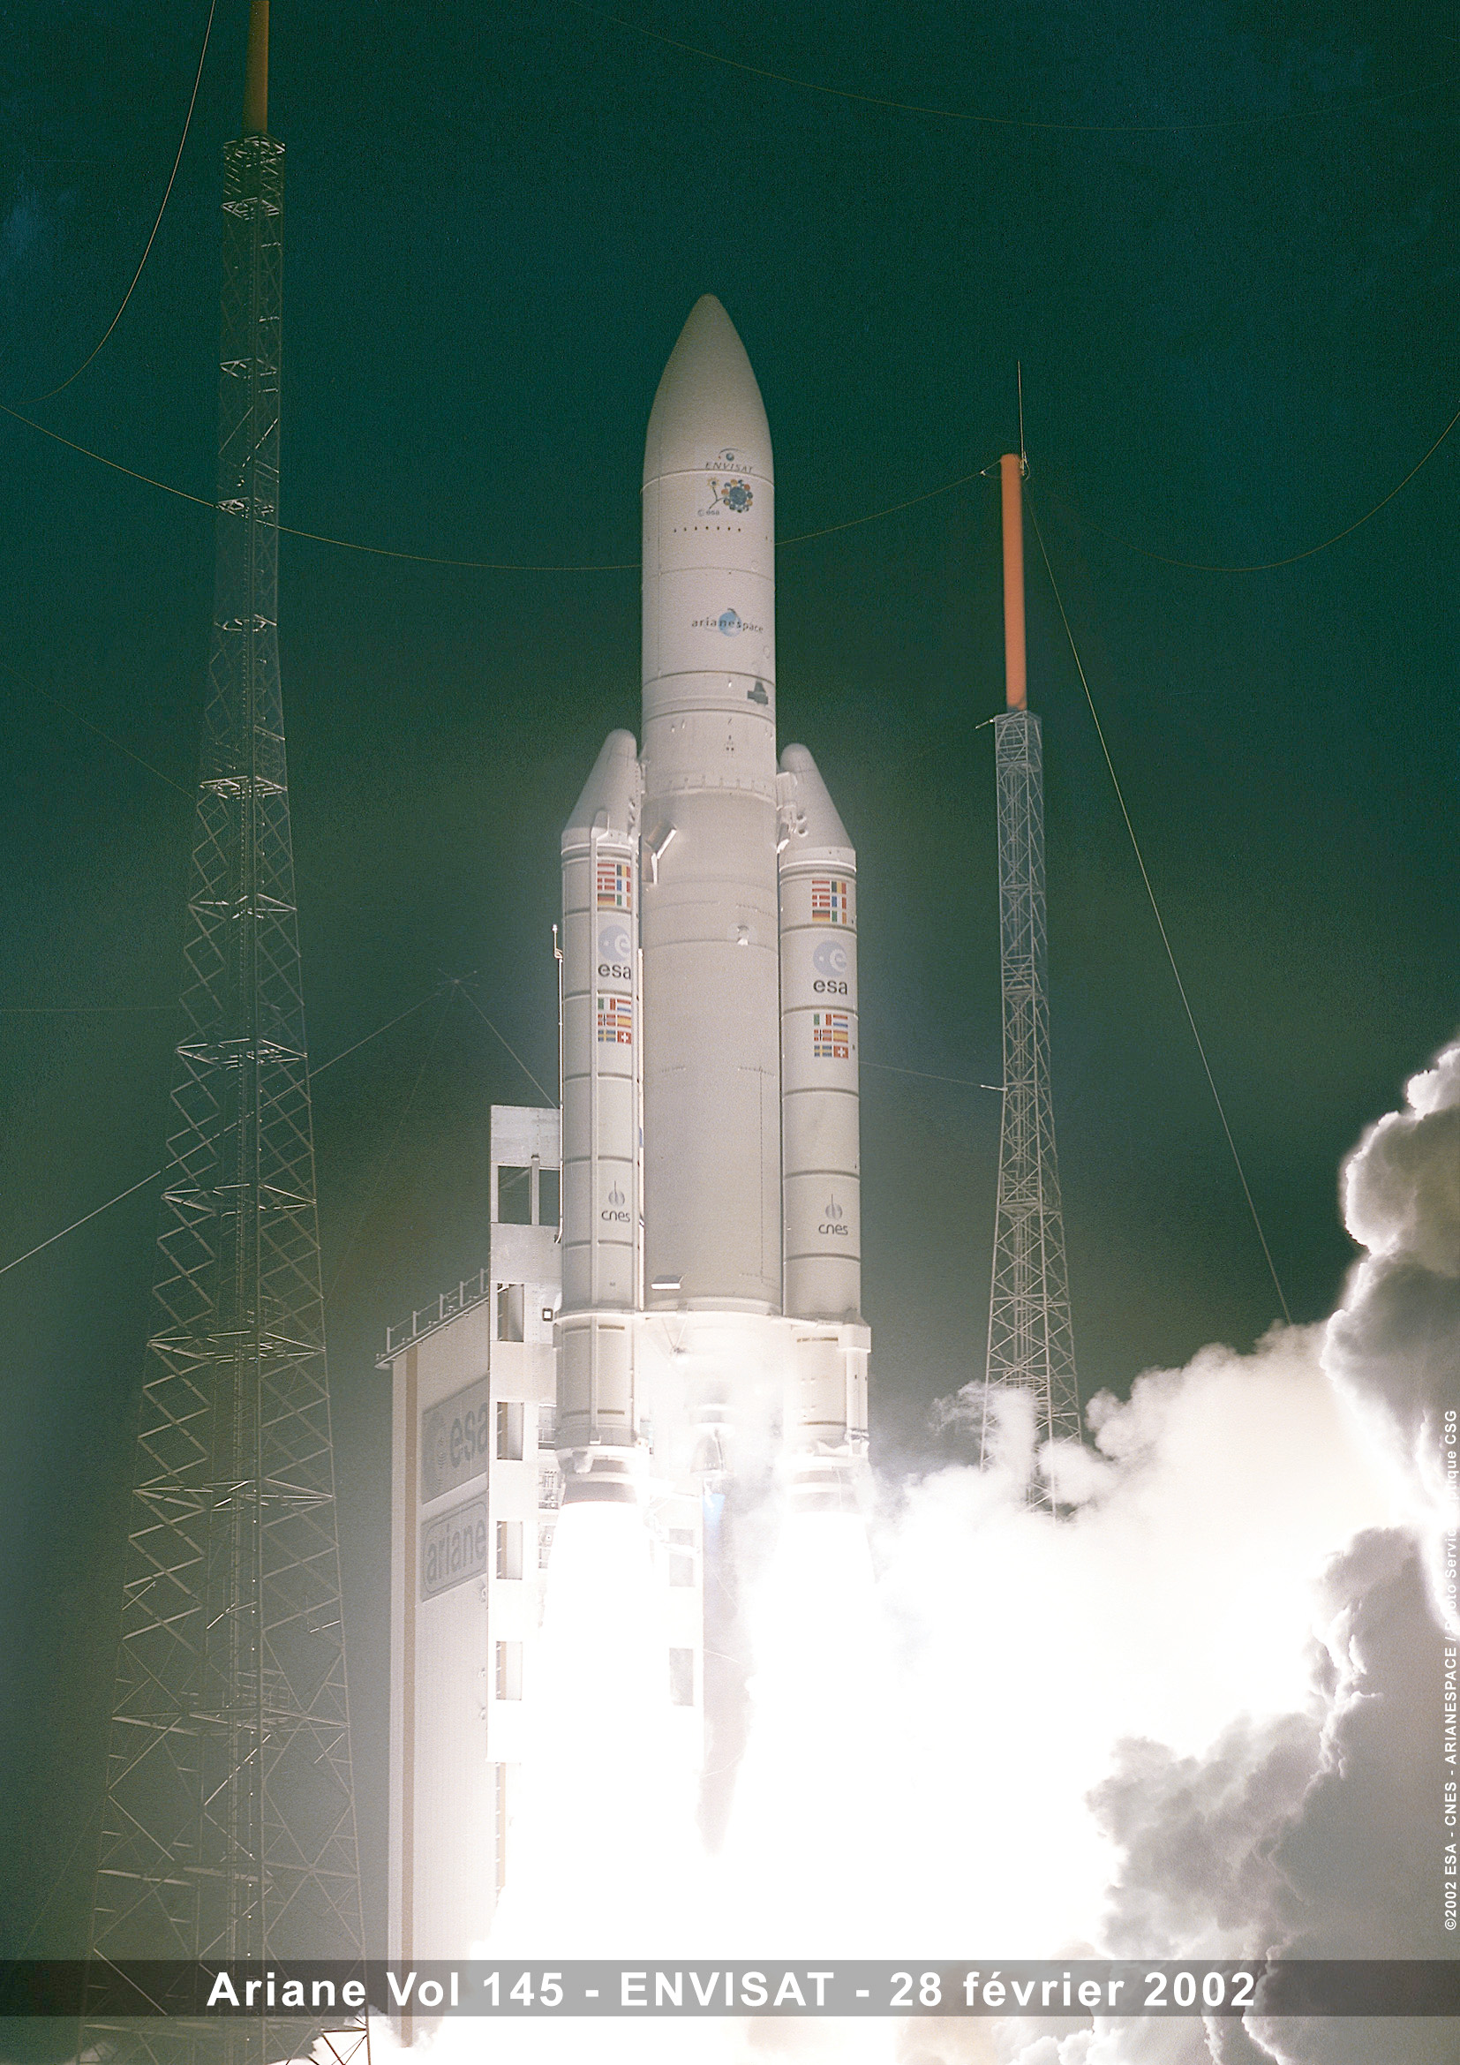
The DoCTA is addressed to students with an B.S. or M.S. degree (or equivalent) and a solid background in science and/or technology, especially graduates in engineering, physics, chemistry or mathematics; candidates from other academic programs may also be considered on a case by case basis. Proven proficiency in English is mandatory.
General objectives: The main purpose of the DoCTA program is to provide specialized research training of graduate students in scientific and technological topics of Aeronautics and Space Systems. Training includes state-of-the-art theoretical and applied courses, as well as methodological aspects and experience on research techniques, with the objective of producing original and high-quality research work (dissertations) in a wide variety of disciplines related to Aerospace.
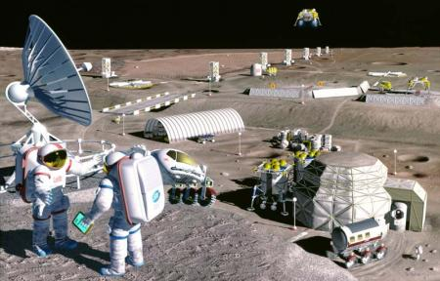
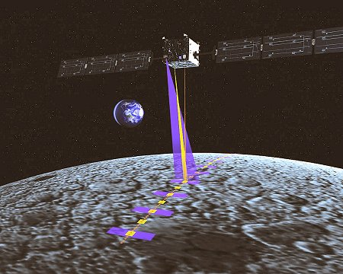
Specific objectives: The contents of the program focus on the fields of aeronautics, scientific instrumentation (payloads) and space missions, remote sensing techniques and their technological and scientific applications. A wide variety of the courses offered deal with the latest advances in the disciplines mentioned above, their methodologies and industrial applications. This approach will provide the student a specialized training and enable him or her to develop research and innovation activities in Aerospace Science and Technology. Given the broad scope and interdisciplinary character of Aerospace studies, the DoCTA is organized in three sections: the Methodology Courses, and two subprograms (Aeronautics and Space Systems) In addition to these, other courses with complementary contents are identified in order to offer a wider vision of the aerospace training possibilities.
Host institution: Universitat Politècnica de Catalunya (UPC)
Web page: http://aerospace.upc.es/PhD
Contact: Prof. Ignasi Casanova (ignasi.casanova@upc.es)

