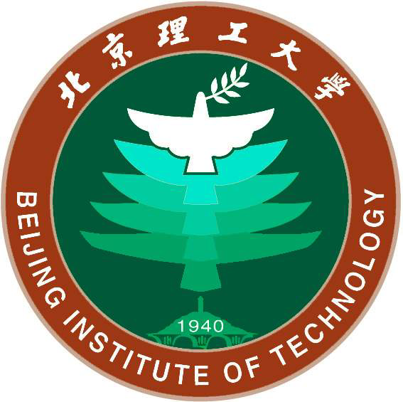

BIT Summer School 2012

(July15- August11 2012)
Overview

The BIT Summer School Program is a four-week program designed for all levels students who are interested in intensive Chinese language studies and culture exchanges at the wonderful Beijing Institute of Technology campus since 2006


Participants will have four weeks of intensive Chinese language study on campus, and weekend off-campus tours to some of China's most important historic and scenic spots. The program combines a four-week intensive Chinese language studies at all levels of Chinese with 7 off-campus culture tours.

To maximize the unique language opportunity in Beijing, each participant is assigned a language partner. Curriculum books and materials will include a series of textbooks.
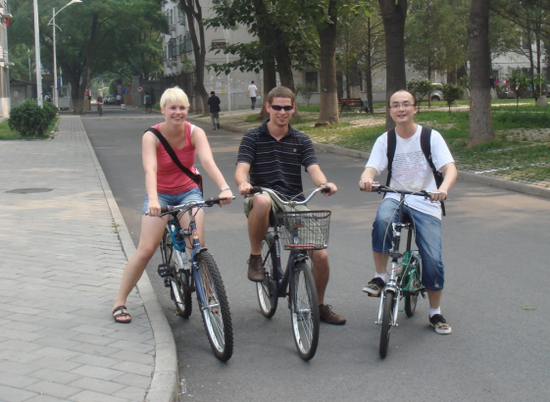
Upon successful completion of program, Participants will be awarded a certificate with an official transcript.
Our language classes require students to practice their skills out in the local environment. BIT's Chinese Studies program provides students the true China experience they seek. All participants will have opportunities to meet Chinese BIT students one-to-one, in order to engage in cultural exchange with TU9 students. This unique arrangement offers the opportunity to practice language skills, make local friends and experience Chinese student life.
Schedule
 | Monday | Tuesday | Wednesday | Thursday | Friday | Saturday
6:40-7:20 |  | Tai Chi |  | Tai Chi
8:40-9:30 | Chinese Language | Chinese Language | Chinese Language | Chinese Language | Chinese Language | Culture Tour
9:40-10:30 | Chinese Language | Chinese Language | Chinese Language | Chinese Language | Chinese Language | Culture Tour
10:40-11:30 | Chinese Language | Chinese Language | Chinese Language | Chinese Language | Chinese Language | Culture Tour
14:00-14:50 | Chinese Language | Chinese Culture | Culture Tour | Chinese Culture |  | Culture Tour
15:00-15:50 | Chinese Language | Chinese Culture | Culture Tour | Chinese Culture |  | Culture Tour
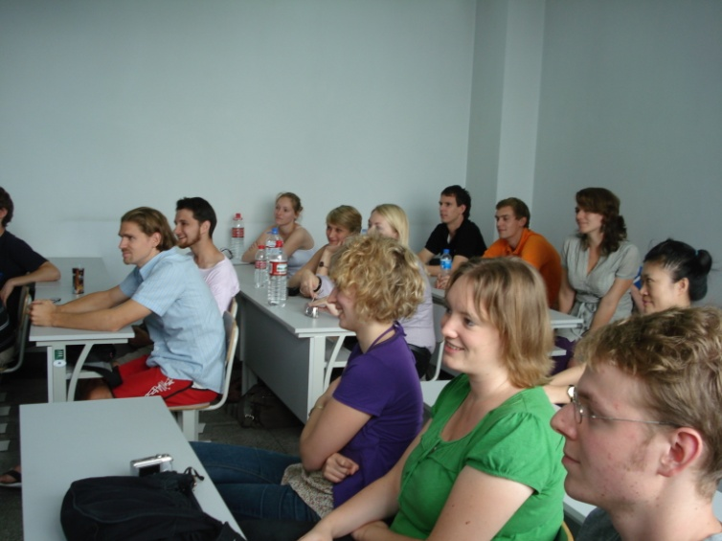
Admission
Applicants must fill out an Application Form. Completed applications must be received in the mail. The application deadline is May 1, 2012. Please do not delay in making your decision because space in this program is filled up rapidly and is on a first-come, first-served basis.
The following application information is required:
- A completed Beijing Institute of Technology Application Form.
- A copy of your passport (Your passport should be valid for at least six months after the end of the program.)
- Two passport photos (Photos printed on regular paper are not acceptable).
VISA Application
You must enter China with a student visa (F visa), which enables you to study at Beijing Institute of Technology for four weeks as an international student. Qualified applicants will receive an admission package, including a BIT Admission Letter, JW202 Form for you to apply for your student visa at the Chinese Embassy or Consulate General of the People's Republic of China close to your school.

Beijing Institute of Technology Application Form
( For 2012 Summer School Program )
International Office BIT (Room 137, No.2 Office Building), Beijing Institute of Technology

Surname |  |  | First Name |  |  | Photo
Name in Chinese  ( if you have ) |  |  | Sex |  |  | Photo
Nationality |  |  | Date of birth |  |  | Photo
Place of birth |  |  | Marriage status | ⁫Single  ⁫Married  ⁫Other: … | Religion
Passport No.  Expiration date |  |  | Which degree  obtained?  when & where ?
Home Mailing Address:
Tel and Fax:
E-mail:
Present occupation & working  company or studying institution |  | Student at UPC-BarcelonaTech (Spain)
Where and how long have you studied Chinese?  Current Level? |  | ⁫ Beginning ⁫ Fair ⁫Good ⁫ Excellent  HSK Test Result: 3 .4.5.6.7.8.9.10?  ( please underline you choice )
Subject of study in China |  | Summer School Program 2012
Which class level do you  Want to attend? How long ? |  | Summer School Program 2012
Comment of sponsor or
recommending party:
Name of agency?
Tel, Fax, E-mail address:
Person to act on your behalf
in China , Name & Address?
Tel, Fax, E-mail address:
Financial Resource |  | ⁫ Myself (own resources)  ⁫ Parents  ⁫ Others: … (please, specify)
Guarantor’s Name & Address:  Tel, Fax, E-mail address: |  | Please indicate their details, only if parents or others.
Date of arrival? |  | (Estimated date between 10th and 15th July 2012, taking into account that the Summer School Programm 2012 starts on 15th July ?)
I hereby affirm that:
【1】 All the information in this form is true and correct;
【2】 I shall abide by the laws of the Chinese Government and the regulations of Beijing Institute of
Technology

Date: Applicant’s Signature:

Important:
1, An incomplete application form or failure to submit the supporting document mentioned above will delay
the process of your application.
2, The tuition will not be returned after five days of new semester due to the student own reason.
Website: www.bit.edu.cn
You may apply first by this E-mail Application Form, and hand in other documents at registration
when you arrive at BIT.
3, Please send to the e-mail: mob.int@upc.edu before 17th May, the following documents:
- this application form
- a copy of your passport (Your passport should be valid for at least six months after the end of the program.)
- including a passport photo

4, Please fill in this form using word ( .doc ) , thanks.

